**OUTPUT SCREENS**

JUnitBasicTesting-Ex1

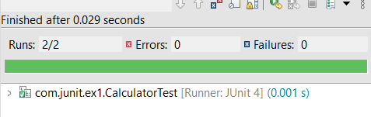

JUnitBasicTesting-Ex3

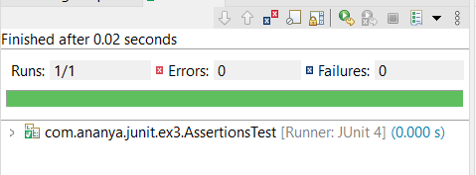

JUnitBasicTesting-Ex4

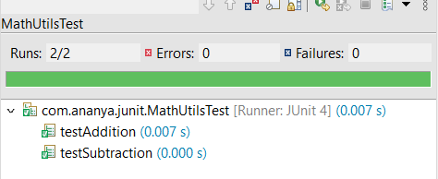

LoggingExampleAppEx-1

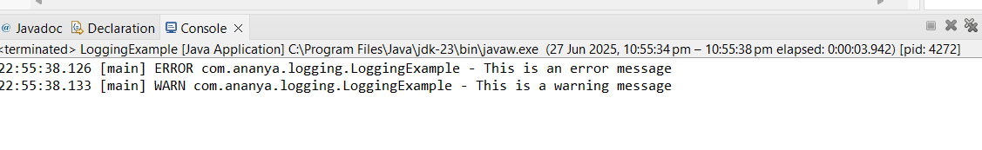

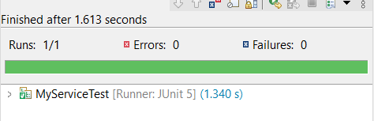MockitoTesting-Ex1

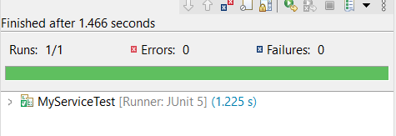MockitoTesting-Ex2

